[syedabsarulhaq@gmail.com](mailto:syedabsarulhaq@gmail.com)

[syedtaha2905@gmail.com](mailto:syedtaha2905@gmail.com)

ABU Robocon - India 2020

Muffakham Jah College of Engineering and Technology

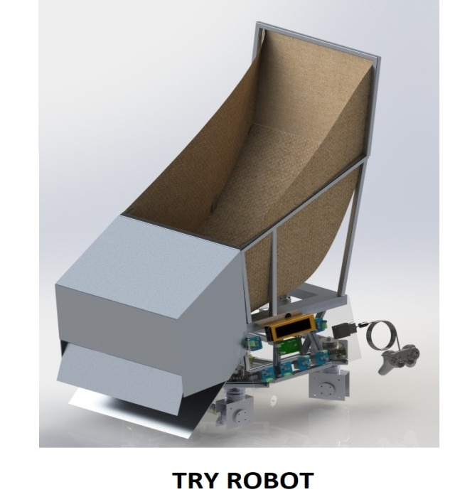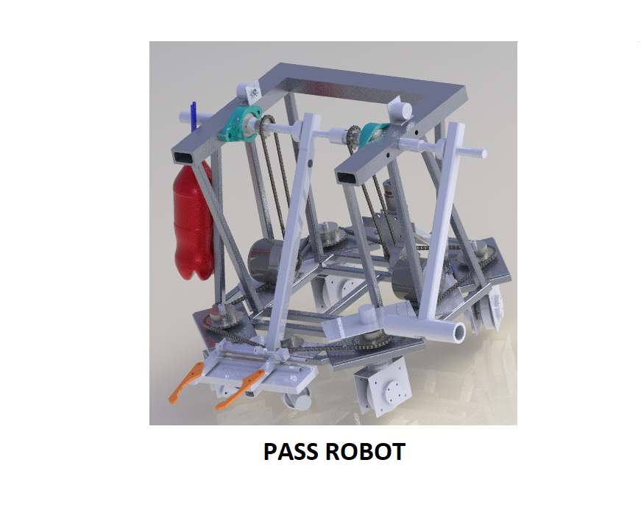

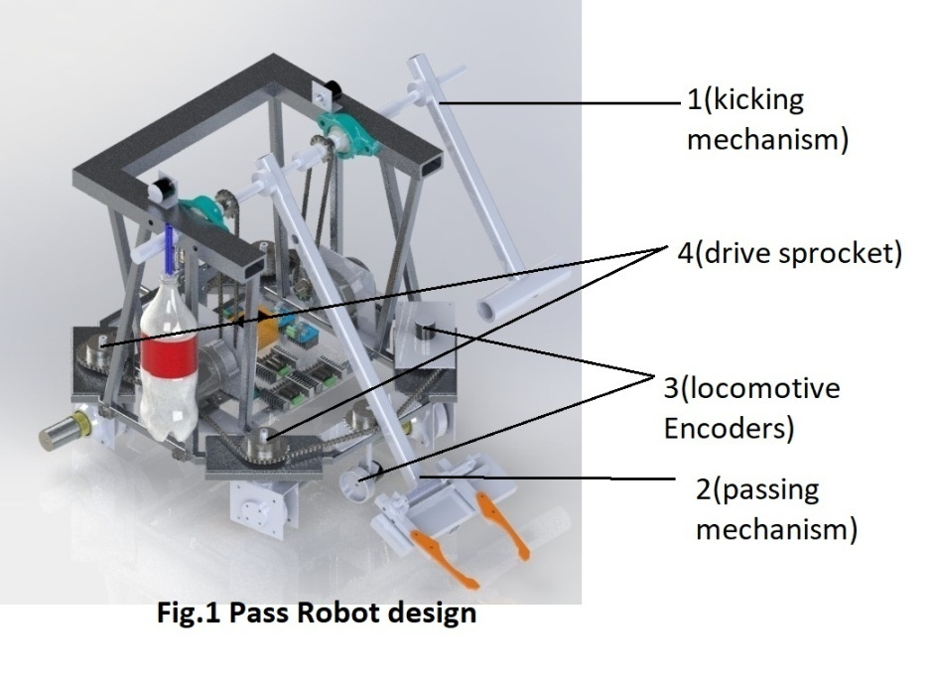**Design of Pass Robot:**

**Specifications:**

|  |  |
| --- | --- |
| Length | 1155mm (full ext.) |
| Width | 1070mm (full ext.) |
| Height | 872.5mm |
| Weight | Approximately 22kg |

**Type of drive: (Maneuvering advantage of synergic four wheel drive over holonomic drive)**

The above robots use a four wheel steerable drive. An Octagonal chassis using 20 x 20 x 2 mm 6061 grade Aluminum square tubes. Aluminum, being lightweight, cost efficient and structurally rigid ensures swift translation and sturdiness.

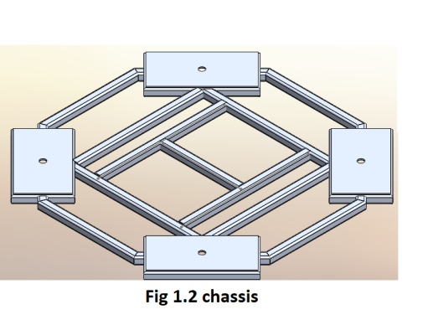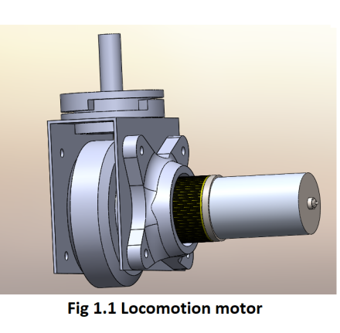Four wheels with individual planetary gear motors are the source of locomotion. They are aligned and rotated synchronously using a chain and sprocket mechanism (fig 1(4)). The wheel casings are attached to sprockets which are attached to a common chain system driven by a single motor. The planetary gear motors (low noise level, great durability and relatively high amount of torque transmission) are used to power each wheel. During translation, each wheel is powered individually to propel the robot while the direction of motion is controlled accurately by the Super Hercules motor (fig1 (1)). An Octagonal chassis is used.

The synergic drive mechanism is used due to its precise working, ease of operation, speed, acceleration and efficiency. The Robot achieves a high amount of stability as all of the motors and the wheels cause the center of gravity to lower.

**List of Actuators and sensors used**

|  |  |  |  |  |
| --- | --- | --- | --- | --- |
| Sl.no | Name and model no | Torque provided | RPM provided | Energy required |
| 1. | Orange planetary geared DC motor 12V | 43 N-cm | 487 RPM | 38W |
| 2 | E bike MY 1016Z3(kick) | 110kg-cm | 324 RPM | 38.37W |
| 3 | E bike MY 1016Z3(pass) | 110kg-cm | 324 RPM | 30.26W |

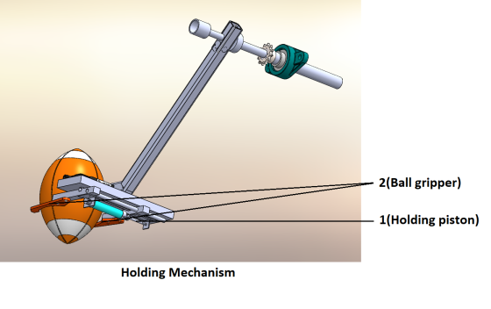**Encoders:** As per the (figure 1(3)), 2 encoders are attached on the locomotion mechanism i.e. on the chassis. The first encoder is attached on the frontal side of the chassis (on a dummy wheel) to monitor the distance traversed by the robot, and the second is attached on the sprocket for the monitoring the direction of motion. Two more encoders are used, one on the passing mechanism and the other on the kicking mechanism. **TF mini LIDAR:** 2 sensors are attached on the right side of the robot to position it for the kick (W.R.T the wall). **Arduino Due:** It is used for the controlling of the robot which is semi autonomous (locomotion is manual and whereas the kicking and passing mechanism are autonomous). **Controller:** A PS2 controller is used for control. **Hercules motor drivers** with a peak current of 13A are used to run the locomotion motors. MDDS30 motor driver with a peak current of 80A is used to control the passing mechanism.

**Ball picking and passing mechanism:**  **Ball Holding:** A robotic arm with two degrees of freedom

(fig 1(2)) with end effectors’ opening greater than the largest diameter of the ball is used (fig 1.3(1)). The ball grabbing mechanism uses a piston (fig 1.3(2)). A high friction material is used to grip the ball. **Passing ball:**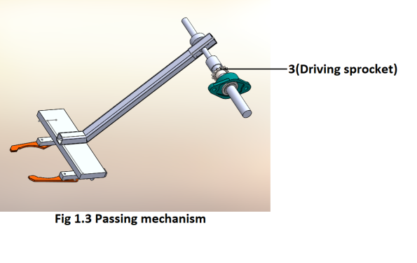The arm is attached to a sprocket which is driven by an E-bike motor (fig 1.3(3)) (which provides more than the power required to pass the ball (which is 30.26W according to our calculations for a distance of 4.7m)). The motor is fixed on the lower part of the chassis and the power is transferred to the sprocket via a chain mechanism (which increases the stability by lowering the center of mass). The pass robot has a type B laser which is fixed at the frontal part of the robot. This laser is used by the pass robot for alignment before the pass.

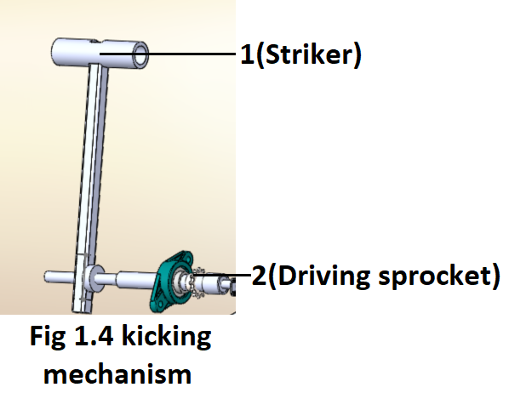Initially the passing mechanism is at rest i.e. parallel to the ground. When the robots are aligned, the passing mechanism starts to rotate and the ball is accelerated to 7.34m/s which launches at an angle of 45ᵒ and has a parabolic path which allows it to cover a distance of 5.5 meters. An encoder is used for precision during release.

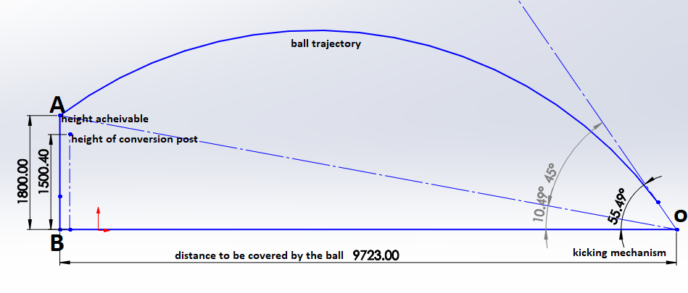**Kicking ball:** The kicking mechanism (fig 1(1)) consists of a cylindrical “foot” (fig 1.4(1)), connected to a “leg” which is attached to a sprocket (fig 1.4(2)). This is driven by a 24 V E-bike motor which also rests on the base of the chassis. The cylindrical block has been chosen for its convex contact area and its symmetry. It is solid so as to increase the mass of the foot and to decrease any loss of energy in the form of any plastic or elastic deformation. The foot length has been calculated to 500mm so as to achieve a kick at an angle of 55.49ᵒ. The ball needs to accelerate to a velocity of 11.1768 m/s, with the foot approaching the ball with an angular velocity of 22.35 rad/sec as the coefficient of restitution of the ball and the foot was found to be 0.8 on experimentation. This acceleration of the foot requires a power of 320W, which is sufficiently supplied by E-Bike motor (power rating: 350W at 24V). Distance from the wall is checked using TF mini LIDAR before every kick for higher precision and accuracy.

**Using the 2d projectile motion equations:**

* In order to kick the ball through conversion post from KZ3 the robot has to rotate at an angle of 22.3 degrees W.R.T receiving zone wall.
* Consider OB=9723mm as the distance between the KZ3 where the Tee is placed and the conversion post.
* Let A be the point on the conversion post that is to be travelled by the ball.
* Let OA be the inclined plane with an angle of 10.49 degrees. Now the distance to be travelled by the ball is OA=9888mm to make a successful goal.
* The ball will travel maximum distance when the angle of projection is 45 degrees.
* Capture.PNGUsing the formula of range as shown.
* The velocity is found as 10.81m/sec.
* Angular velocity =v/r=19.654 rad/sec.
* Angular velocity=2*pi*N/60.
* Therefore N=187.68 RPM, maximum height reached by the ball is 4050mm.
* Power required to kick the ball at a distance of 9888mm=2*pi*N*T/60=38.37W.
* Ball kicked from KZ3 will reach a height of 2300mm**>**obstacle’s height(1200mm)

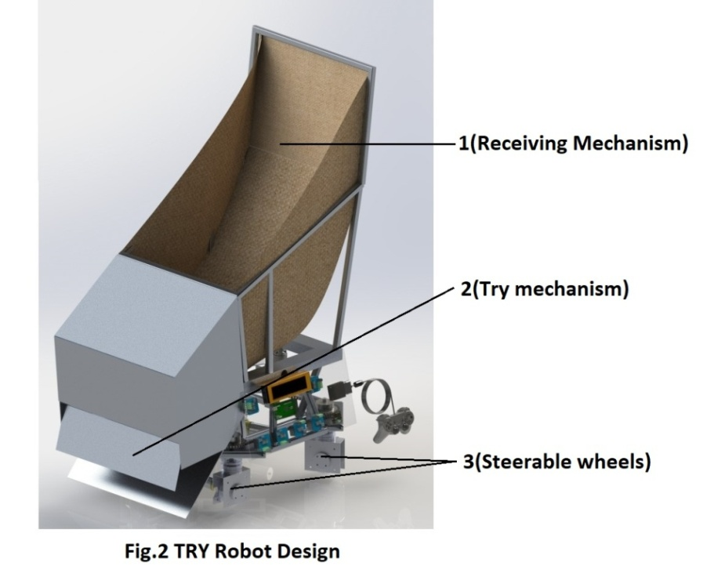

**Design of Try Robot: Specifications:**

|  |  |
| --- | --- |
| Height | 1350mm |
| Length | 920mm |
| Width | 610mm |
| Weight | approximately 18kg |

**Type of drive:** The same synergic drive mechanism is used as used in the pass robot.

**Comparison of speed for different locomotion drive:**

|  |  |  |
| --- | --- | --- |
| Sl .no | Type of drive | Resultant speed( |
| 1. | Holonomic plus drive | 2R. |
| 2. | Holonomic cross drive | . |
| 3. | Steering drive | 4R. |

From the comparison **the steering drive has an advantage** in terms of **speed** when compared to the other drives.

|  |  |  |  |  |
| --- | --- | --- | --- | --- |
| Sl.no | Name of motor | Rated torque | Rated speed | Speed to be achieved |
| 1. | Tauren motor | 4.38 kg-cm | 487 RPM | 400 RPM |
| 2. | Super Hercules | 150kg-cm | 100 RPM | 20 RPM |

**Actuators and sensors integrated: Arduino mega** is used for controlling all the actuators and functions of the robot.  
**Actuators**: Four tauren motors are used for locomotion. Super Hercules motor is used for steering the robot. A linear actuator is attached at try mechanism for TRY.   
**Encoders** are attached for semi autonomous locomotion.  
Linear actuators are controlled using **PS2**.  
**Motor driver:** **L298N** (peak current 2A) is used for controlling the linear actuator.

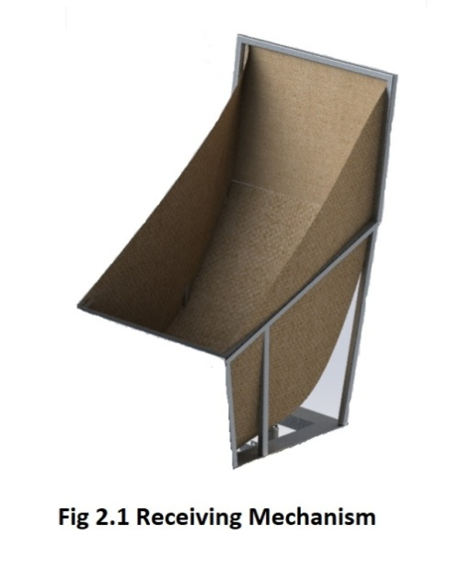**Ball receiving mechanism:**  
The launched ball is received (fig 2(1)) by the TR in a funnel like structure which is covered by nylon cloth in order to damp the 75.5N force of the ball which was accelerated at a speed of 6.64m/s. The funnel is extended in vertical axis i.e. 385mm in order to avoid a miss. The ball travels through the funnel and stops at the close end of funnel, the ball is ready to try at try mechanism.

**Try mechanism:**

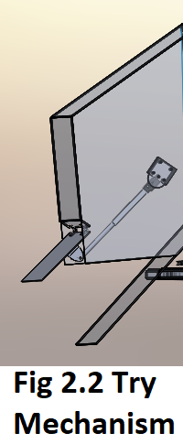The try mechanism (fig 2(2)) consists of a plate hinged to the upper casing and pivoted to a linear actuator which is normally in contracted position. As soon as the TR reaches the try zone, the plate is pushed by the linear actuator i.e. the plate opens slowly and the ball rolls on the lower plate. The plate is made at an angle of 47ᵒ W.R.T ground in order to decrease the rolling speed and the length of the plate over which the ball has to roll is taken as 395mm so that the ball lies in contact of try zone, and robot as per the rule 19-a.